Australian Films Source Analysis

Source 1

The Adventures of Barry McKenzie (1972) trailer
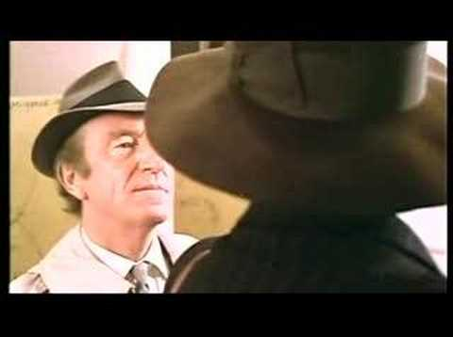

Name of the source: | The Adventures of Barry McKenzie Trailer (1972)
How does the film depict Australians?

How does the film depict the British?

What can this source tell us about how Australians saw themselves in this decade?

What was the purpose of this source?

Source 2

Crocodile Dundee - Trailer

Name of the source: | Crocodile Dundee Trailer (1986)
How does the film depict Australians?

How does the film depict the British?

What can this source tell us about how Australians saw themselves in this decade?

What was the purpose of this source?

Source 3

Australia Trailer HD

Name of the source: | Australia Trailer (2008)
How does the film depict Australians?

How does the film depict the British?

What can this source tell us about how Australians saw themselves in this decade?

What was the purpose of this source?

Paragraph Writing

Based upon what you have learnt in your source analysis, answer the question below in paragraph format (Topic Sentence, Explanation, Evidence, Concluding Sentence):

How have Australians portrayed themselves in films since the 1970s?

