Aztec Religion Source Analysis

Step 1: Understanding source analysis
The first thing we need to learn is what ‘source analysis’ means in History. Read the following webpage and answer the questions that follow:
Read: https://www.historyskills.com/source-criticism/analysis/

- What is 'source analysis'?

- What are the six analysis skills used in History?

- What two questions do we need to answer to understand the origin of a source?

Step 2: Understanding source origin
Watch the following video and answer the questions that follow:
How to analyse a historical source's origin
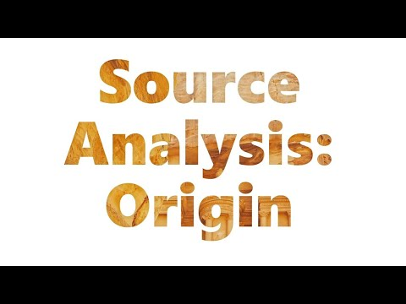
- The origin of a source is...

- The two things you need to state for source origin are:

- In order to state these two things, you will need to...

- When a creator's name is not known, you need to...

- In the first example, who was the source creator?

- In the second example, what type of source was it?

Step 3: Analysis of sources

Using the assigned sources for this activity, answer the questions that follow:

Source 1

- According to Source 1, what did Aztec priests do as part of their religious duties?

- According to Source 1, why was human sacrifice important to the Aztecs?

- According to Source 1, who was sacrificed?

- What is the origin of Source 1?

Source 2

- In what ways does Source 2 corroborate Source 1?

- What is the origin of Source 2?

Source 3

- What type of source is Source 3?

- What is the origin of Source 3?

- Where is Source 3 located today?

Paragraph Writing
Based upon what you have learnt in your source analysis, answer the question below in paragraph format (Topic Sentence, Explanation, Evidence, Concluding Sentence):

Why was religion an important part of Aztec life?

In your response, use direct quotes and in-text referencing from the sources above.

